India tour 14-30 November 2018
Jaisalmer in Desert - Golden City
Day 7:- Jaisalmer day 2, extras.
The extraordinary details of the Jaisalmer fort require another set of photographs to give it justice. Your indulgence please for some of Alan’s other photos.
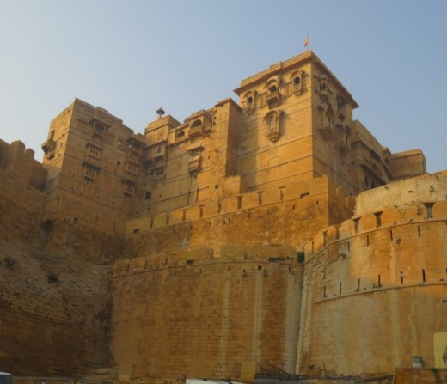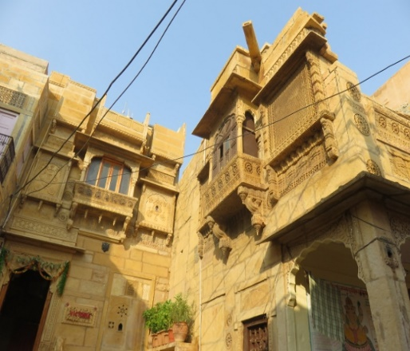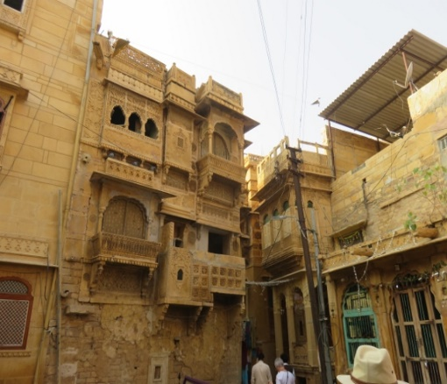
Massive buttresses internal windows looking out to alleyways some more residences.
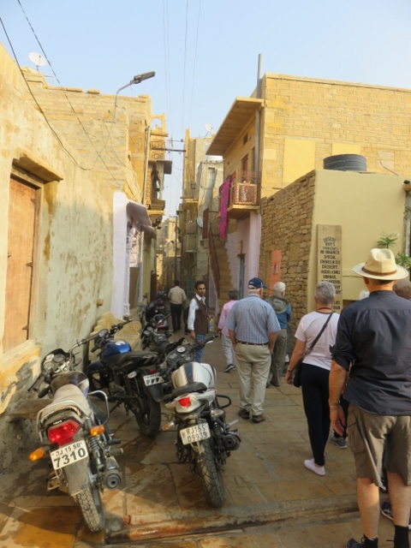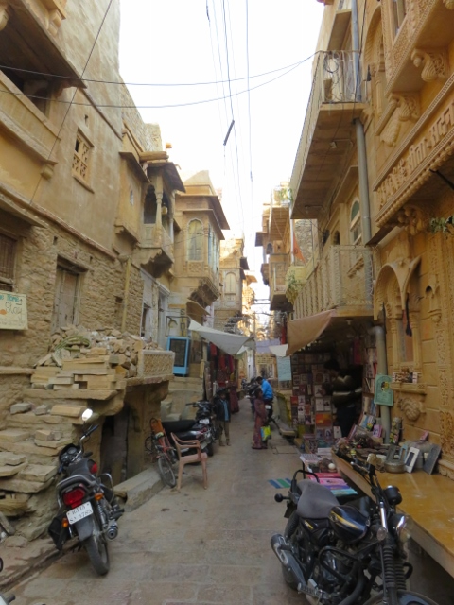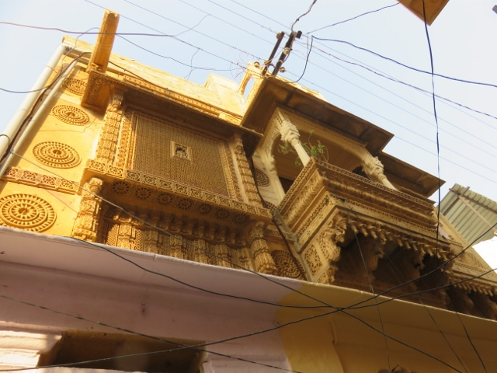
Yes motorbikes get up into alleyways some more decorations outside house in fort.
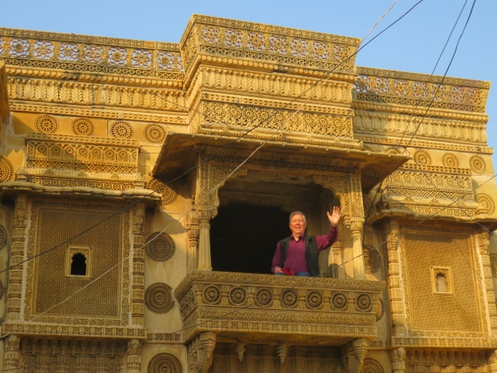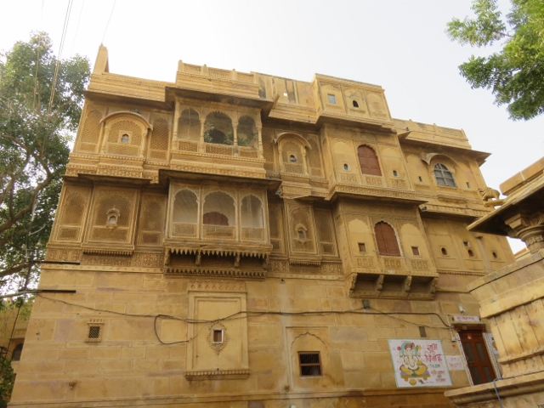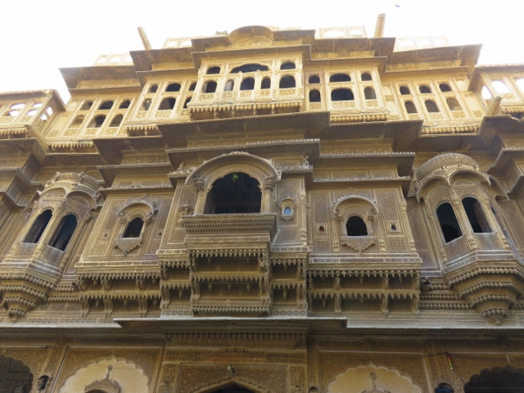
Alan paid 20 Rupees to get inside to balcony Windows for women’s quarters the brothers dual house.
While wandering around the Fort’s internal alleyways the group came across everyday life for the residents. They parked their motorbikes outside the entrance to their places, cows and bulls roamed at will. One had to be careful of the excrement droppings from those animals on the cobble stone alleyways. How they climbed up the stairs had to be seen to be believed. The views from the bastions was great although the pollution hazed the distances. Tour guide calls it water vapour in the atmosphere. If you believe that – good luck!
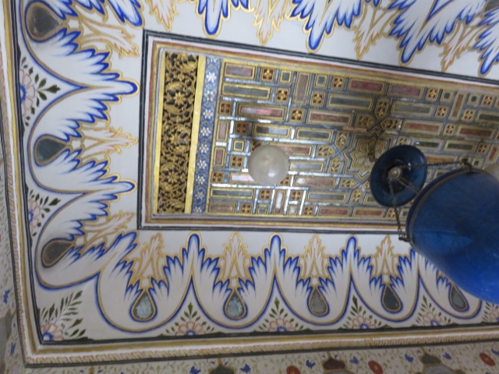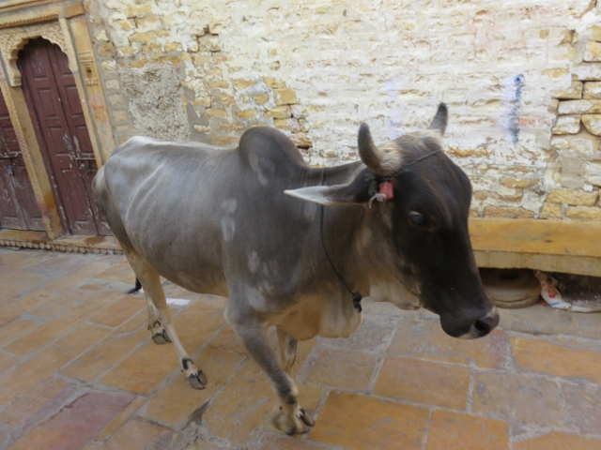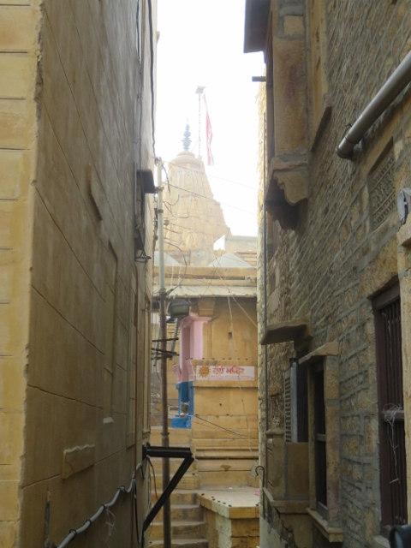
Ceiling in brother’s house bull strolling through fort alleyway view of temple through alleyway.
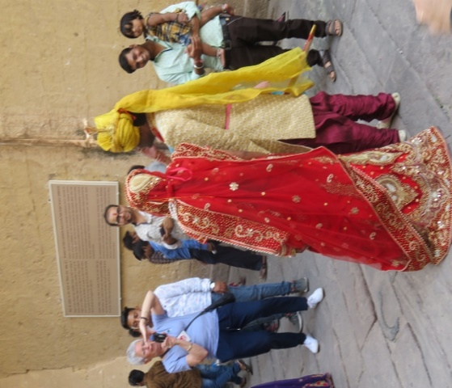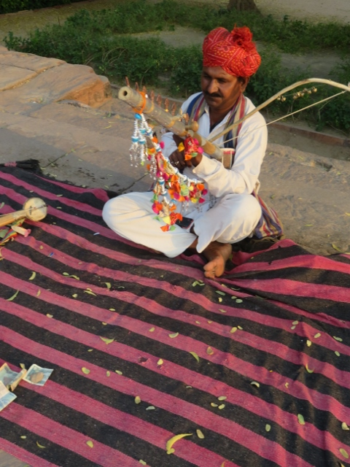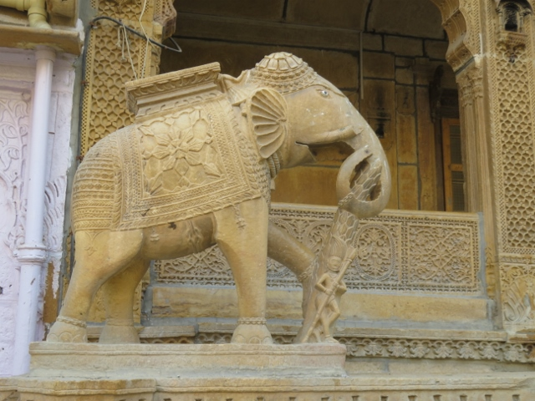
Indian wedding couple viol player seeking contributions decoration at entrance to brother’s house.
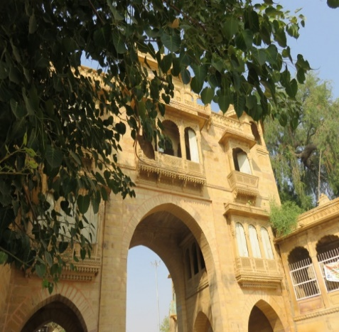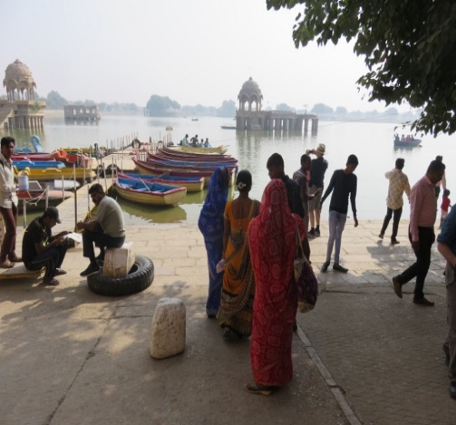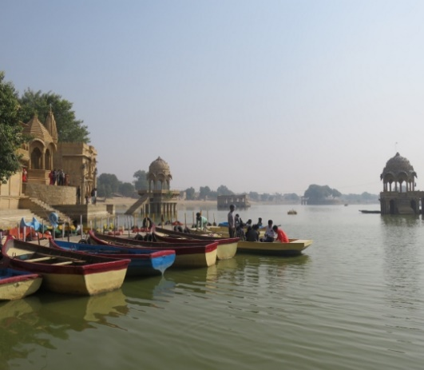
Entrance gate to tank lake water’s edge at Tank Lake boats at Tank Lake
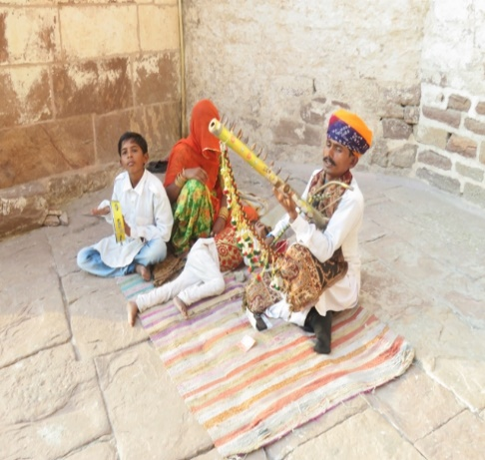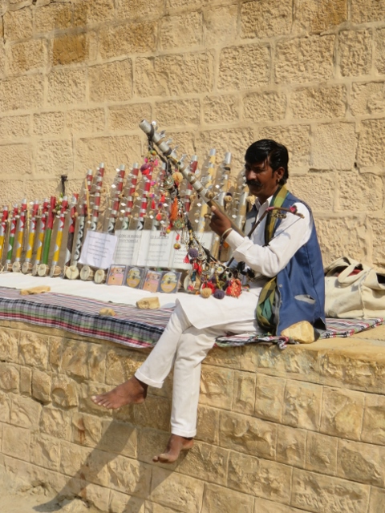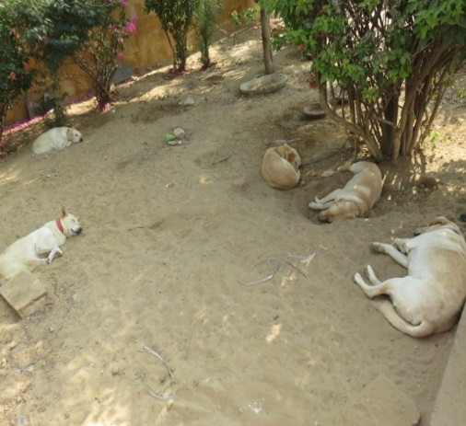
Musician an off sider at tank lake musician plying sales of instruments best to let sleeping dogs lie.

